**Methods Summary:** FR1 & FR2

# General Design

* Introductory video describing task
* Practice list preceding the first experimental list.
* 12 word lists; 25 lists per session; two sessions on consecutive days (four sessions total)
* 10 second countdown preceding the encoding phase of each list
* Encoding: 1600ms word presentation. Randomly jittered ISI 750-1000ms.
* Distractor (20s): A+B+C = ? math problems, where A/B/C are random integers 1-9
* Retrieval (30s): free recall in any order
* Time on task for 25 lists/session: ~ 34 min

# Task Schematic

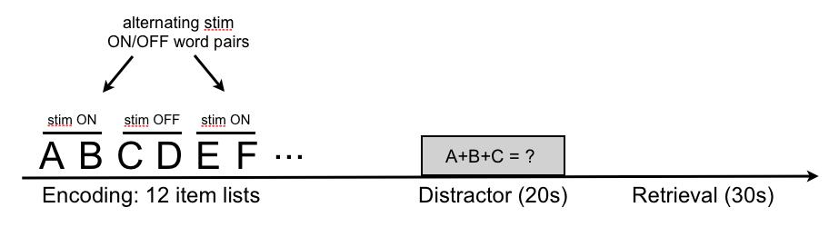

# Word Lists

* The word pool is adapted from the word pool used in the pyFR task, which has been run in a set of over 150 intracranial patients (Burke et al., 2013; Long et al., 2014).
* A set of 300 words was chosen from the pyFR word pool, based on the recall performance of a separate set of participants who completed a large-scale study of free recall (24 sessions per participant). Recall performance in this large-scale task was modeled to estimate the effect of each individual word on recall, removing influences of serial position and frequency, concreteness, imageability and length. Estimates for the words were used to identify the words at the top and bottom of the distribution for removal.
* Word lists were constructed from the remaining 300 words according to an algorithm that generates unique lists with mean pairwise LSA similarity within list ~ .2.
* Word lists will be randomly assigned to stimulation conditions.
* All 300 words in the pool will be seen once in Session 1, and then seen a second time in Session 2. The *lists* will be unique across Sessions 1 and 2.

**Stimulation Parameters:**

For the first cohort of participants, stimulation parameters (amplitude, frequency, and location) will be chosen to match stimulation from prior work showing stimulation-related enhancements in memory performance (Suthana et al., 2012). (*Note*: amplitude, frequency and location will be set manually by the clinician for System A).

*Parameters fixed across first cohort of participants:*

Stimulation amplitude:**1.5 mA (or 0.5 mA below afterdischarge threshold)**

Stimulation frequency: **50 Hz**

*Parameters varied within participant:*

Stimulation location: **hippocampus and entorhinal cortex**

*Other Stimulation Parameters:*

* Bipolar stimulation
* Pulse width: 600 microsecond pulse (300 us per phase)
* Duration: 4.6 s

*Timing of Stimulation:*

* Stimulation will be applied during the encoding phase of the task. The Distractor and Recall phases will not be stimulated.
* Stimulation will occur in alternating two-word blocks and will alternate within each list. Stimulation will always be triggered 200ms prior to onset of the first word in the block and will last for 4.6 seconds. Depending on the length of the jittered ISI interval between the words, stimulation will therefore terminate 200-450 ms after offset of the second word.

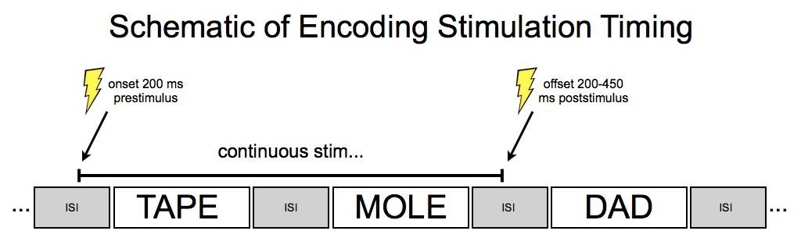

*Assignment of Word List to Stimulation Condition:*

* Out of the full set of 25 lists in a session, 5 lists will be randomly assigned to the null condition--i.e. no stimulation for the entire list. The remaining 20 lists will be randomly and evenly assigned to the hippocampus/EC conditions.
* The order of hippocampus/EC stimulation conditions will be blocked within a participant and counterbalanced across participants. Blocking the design within participant will minimize time spent manually updating settings on the stimulator.
* The order of stimulation *within a list* (i.e. whether the list begins with a stim ON pair or a stim OFF pair) will be randomly assigned to each list, with the constraint that at the end of the session, 10 lists will belong to one condition and 10 lists will belong to the other (the remaining 5 lists per session will be completely no-stim).
* Lists in Session 2 are yoked to lists in Session 1 such that across two sessions, any word that is stimulated in one session is not stimulated in the other session.

# Experimental Design Power Analysis (assuming 25 lists/session and 2 sessions)

* *The experimental design shall be statistically powered to have at least a 90% probability of identifying a 0.7 standard deviation difference between the stimulation and no-stimulation conditions.*
* The power analysis estimated power to detect an overall difference recall between stim and no stim trials. The probability of recalling a given word in the no-stim condition was modeled as a binomial distribution with p = .5. For the stim condition, probability of recall was also modeled as a binomial with p = (.5)+(.7)SD, where SD for each simulated subject is drawn from the empirical distribution of within-subject across-session SD in overall recall performance, for all participants in the pyFR dataset. Random draws from these binomial distributions were simulated jointly over number of trials within a patient and number of patients. This process was repeated 1000 times for each combination of # trials and # patients, and the proportion of t-tests that detected a significant difference between the conditions was used as the estimate of the design’s power.
* For the within-subject comparison of region, **Nmin = 12.**

# References

1. Burke JF, Zaghloul KA, Jacobs J, Williams, RB, Sperling MR, Sharan AD & Kahana MJ (2013). Synchronous and asynchronous theta and gamma activity during episodic memory formation. *Journal of Neuroscience*, 33(1), 292-304.
2. Long NM, Burke JF & Kahana MJ (2014). Subsequent memory effect in intracranial and scalp eeg. *NeuroImage*, 84, 488-494.
3. Suthana N, Haneef Z, Stern J, Mukamel R, Behnke B, Knowlton B & Fried I (2012). Memory enhancement and deep-brain stimulation of the entorhinal area. *New England Journal of Medicine*, 336, 502-510.